PERSONAL INFORMATION | Amna Mohammed Osman Ahmed
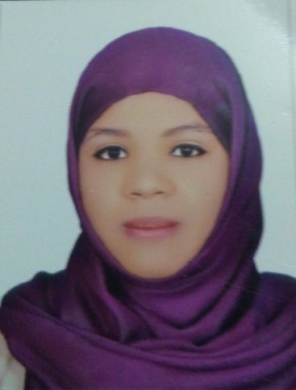  e | 450 Block 12,Al-kalakla, Khartoum, Sudan.  Faculty of Petroleum and Minerals, Al Neelain University, Khartoum ,Sudan.
 | +249 905535390
 | amnasas993@gmail.com
 | https://www.facebook.com/amna.mohmed.77
 | | Date of birth\08/05/1993| Nationality Sudanese Sex Female
RELIGION Muslim
MERITAL STATUS Single
STUDIES APPLIED FOR personal statement | B.Sc. Honour in Geology (First Class).

WORK EXPERIENCE
Work Experience  Organisational / Managerial Skills | - Teaching Assistant( full time teaching assistant ),department of Geophysics /Faculty of Petroleum & Minerals, since march 2015 until now .  - Leadership (Head of Geology Association at Al Neelain University from march 2014-2015).

EDUCATION AND TRAINING | - B.Sc. Honour(First class, 84.55%) in Geology, Faculty of Petroleum & Minerals ,AlNeelain University ,Khartoum ,Sudan.  - A period of training from (29-11-2015 – 3-12-2015) at the center of construction and environmental laboratories, Khartoum, in the following categories:  - Department of Soil  - Department of Concrete  - Department of Asphalt  ,

PERSONAL SKILLS | - Strong ambitious and intelligent personality.  - Ready to work for long times and under pressure.  - Capable to work in both individually and in a team.  - Software: MS Office (word, PowerPoint and Excel)  - Geology Software: ArcGIS, ENVI, Rockworks, Surfer and Google Earth  - Microscopic Skills: Transmitted light microscope, Polarized light microscope.

Mother tongue(s) | Arabic
Other language(s) | UNDERSTANDING |  | SPEAKING |  | WRITING
Other language(s) | Listening | Reading | Spoken interaction | Spoken production
English | V.Good | Excellent | Good | Good | Excellent
Communication skills | - Good communication skills gained through my experience and during my study.

.

a

Projects  References | - Graduation dissertation entitled(Evaluation of building material in Khartoum state)January2015.  - Regional Geology of Sudan,march 2014.  - Geological Mapping of the Eastern Part of Sabaloka Inlier , June 2013.  - The Geology of Sabaloka Inlier ,march 2012.  - Dr .NuhaElzein Mohamed, Associate Professor of Geophysics,Faculty Of petroleum and Minerals - AlNeelain University.nuhazein@hotmail.com , +249912368128.  - Dr. Abdullah Elhag Ibrahim,Associate Professor of Geophysics ,Faculty Of Petroleum and Minerals - Al Neelain University.bdllibrahim@yahoo.com , +249915566017.  - Dr. Jamal abd allah altum Associate Professor of Geophysics ,Faculty Of Petroleum and Minerals - Al Neelain University gamalabdalla@yahoo.com ,+249912369003.

