C.V
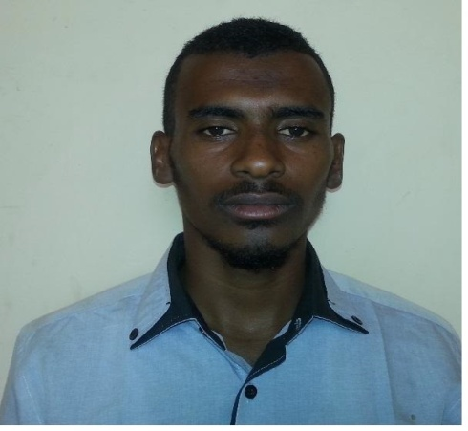

Personal information: - Name: Ali Ahmed Mohieldain Ali.
Place of birth: White Nile State- Sudan.
Date of birth: 23\March\1990.
Address: Khartoum State- Ummbda Locality- Alrian Block- House NO. 1146.
Nationality: Sudanese.
Marital Status: Married.
Religion: Muslim.
Passport No.: P00788277.
Place of issue: Omdurman.
Date of issue: 28/Feb./2013
Valid Drive License No.:M01K924263.
Place of issue: Khartoum.
Date of issue: 22/Apr./2014.
Phone No.: +249919066641_ +249913300879_+249911607501.
E mail: aliaction90@hotmail.com.

Qualification:-
B.Sc. Honors in Geology with degree first class (84.66%) in 10 Sep.\2012 from Faculty of Petroleum & Minerals _ Department of Geology _ Al Neelain University.

Present Occupation:-
Full-time teaching assistant at Department of Geophysics, Faculty of Petroleum and Minerals, Al Neelain University since June 2016.
Experiences:-
-Fourth field trips in different years of study at Al Neelain University addition to graduate project in THE GEOLOGY AND TECTONIC SETTING OF BUTANA AREA EAST- CENTRAL SUDAN.
-Part-timer teaching assistant at Al Neelain University- Faculty of Petroleum and Minerals- Department of Geology for academic year 2012-2013.
-Participant in numbers of field trips with under graduate students.
- Exploration Geologist at Sandra Mining Company from May\2013 up to Jun\2014.
- Exploration Geologist at Kambal Mining Company from Dec\ 2014 up to May\ 2016.
Skills:-
- Mapping; Regional and detailed geological maps and sampling.
- Trenching; full documentation.
- Artisanal pit sampling.
- Logging, sampling (full documentation) of Drilling samples (Core &RC).
- Insertion of QA/QC reference samples.
- Structural interpretation.
- Supervising Sample preparation (Crushing, Quartering, Milling and Packing).
- Stream sediments and soil sampling program (Pitting & Panning).
- Digital data capture and database management of all data collected
- Excellent skills acquaintance with computer processing and creating database on (Arc GIS) and other Geo programs.
-Language: Arabic (mother tongue) – English fluently (IELTS 5.5 of academic model in 13/Dec/2014).
-Software’s: Microsoft Office (good) and other Geology software’s (GIS (elemental), ENVI (good), Corel draw (medium)).

Referees:-
Dr. Nuha Elzein Mohamed
Associate professor, Department of Geophysics, Faculty of Petroleum and Minerals, Al Neelain University, Khartoum, Sudan. Email: Nuhazein@hotmail.com

Dr. Khalid Abdelrahman Elsayed
Associate professor, Department of Geology, Faculty of Petroleum and Minerals, Al Neelain University, Khartoum, Sudan. Email: kalsayed2001@yahoo.com.

Dr. Abdalla Eltom Mohamed Elsheikh
Associate professor, Department of Hydrogeology, Faculty of Petroleum and Minerals, Al Neelain University, Khartoum, Sudan. Email: abdalla.elsheikh@gmail.com.

